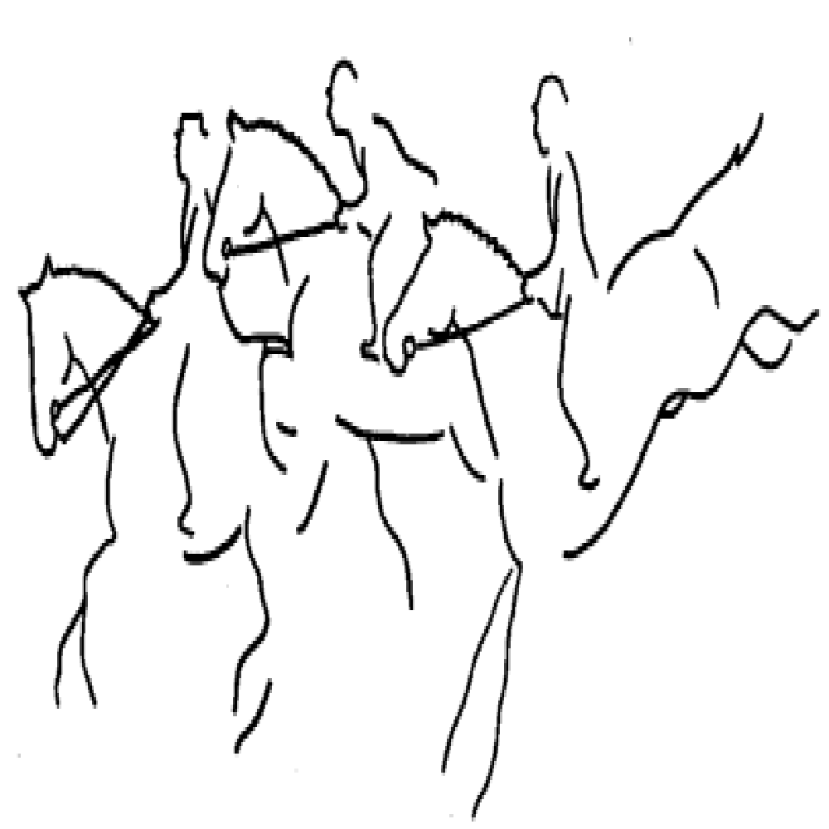
Manitoba Horse Trials

October 2018
Dear Merchant
Manitoba Horse Trials (MHT) is a non-profit local equestrian group dedicated to promoting 3-Day Eventing in Manitoba. Three-Day Eventing is the triathlon of equestrian competition; it combines the disciplines of dressage, cross-country, and stadium jumping. Our club grounds and the majority of our events are held just outside of Winnipeg in beautiful Birds Hill Park.

Members and board members of MHT are currently soliciting local businesses for prizes to hold a silent auction at their Bud, Spud & Steak fundraiser on November 10th,, 2018 at The Peppercorn Restaurant, Oakbank. The silent auction and draws are important events that help make the fundraiser entertaining, memorable, and successful.

All proceeds of this event will go towards improving eventing in Manitoba. At this time, MHT is in the midst of rebuilding our courses on the grounds of Birds Hill Park. MHT events require a tremendous commitment from volunteers and members, who not only prepare to ride in the event, but prepare the courses they compete on as well. Our organization is entirely volunteer based; the members of our community include people from all walks of life across Manitoba who all have a common love of horses, nature, and the great outdoors!

We would greatly appreciate any donation that your business could provide. All donations are publicly acknowledged, which provides positive advertisement for your company. Please ensure that a contact name and address is attached to any donation, as we would like to properly show our appreciation.

If you have any questions, please feel free to contact the bearer of this letter or myself Deborah Shepherd.

Sincerely,

Deborah Shepherd
Manitoba Horse Trials
deb_shep1@yahoo.co.uk
12047859343

